DSO- 545 Final Project

LA 311 service request Data analysis

Imaad Khan, Julianna Han, Shuhan Zhou, Yifan Wu, Yuzhou Dou

December 7, 2016

Table of Contents

OBJECTIVE 3

METHODOLOGY 3

ANALYSIS 3

*Basic Distribution* 3

*Time Series/Efficiency in Handling Requests* 6

*Maps/Spatial Visualizations* 8

RECOMMENDATIONS 11

CONCLUSION 12

SOURCES 13

# **OBJECTIVE**

This is our team’s analysis of the 311 call center/service request dataset. In this report, you will find key insights and learnings along with recommendations on how the City of Los Angeles’ 311 department can better service its customers.

# **METHODOLOGY**

Our team decided to approach this project by performing various graphical analyses in the R programming software. The areas we chose to focus on are:

* Basic Distribution of the Service Requests
* Time Series Analysis/Efficiency in Handling Requests
* Maps/Spatial Visualizations

# **ANALYSIS**

## *Basic Distribution*

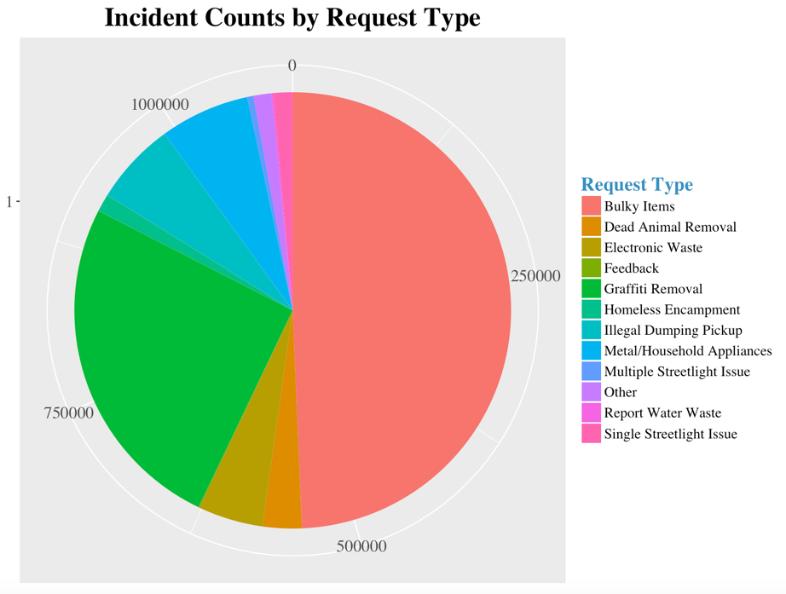

We can tell that Bulky Item Removal counts for nearly half of the total reports followed by Graffiti Removal.

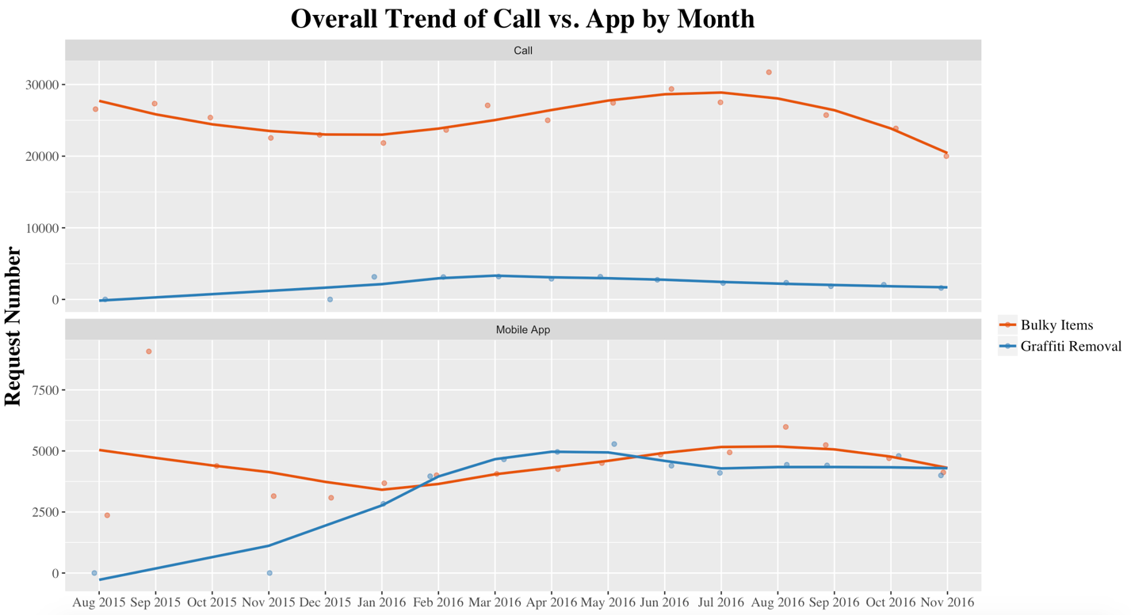

We explored the two highest volume service request categories (Bulky Items and Graffiti Removal) over time. It is evident from this graph that a higher percentage of people who report Bulky Items versus those who report Graffiti Removal call the 311 service line instead of using the mobile app. This could be due to the perception that a call will resolve the issue faster and that people are more adversely affected by bulky items in their street than they are by graffiti.

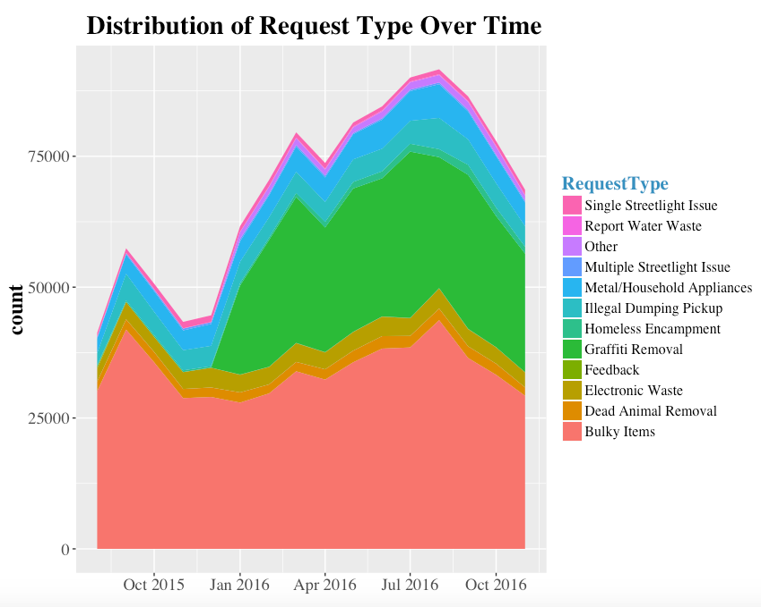

This graph illustrates the change in request types over time from September 2015 to November 2016. It is interesting to note the spike in Graffiti Removal requests beginning in January of 2016.

This coincided with LA Mayor Eric Garcetti’s 2016-2017 City Budget proposal, which added $1.5 million added for 13 new strike teams to help address the city graffiti issue and is a positive example of local government responding to new request demand by observing 311 data.

**Request Handling Time by Request Source**

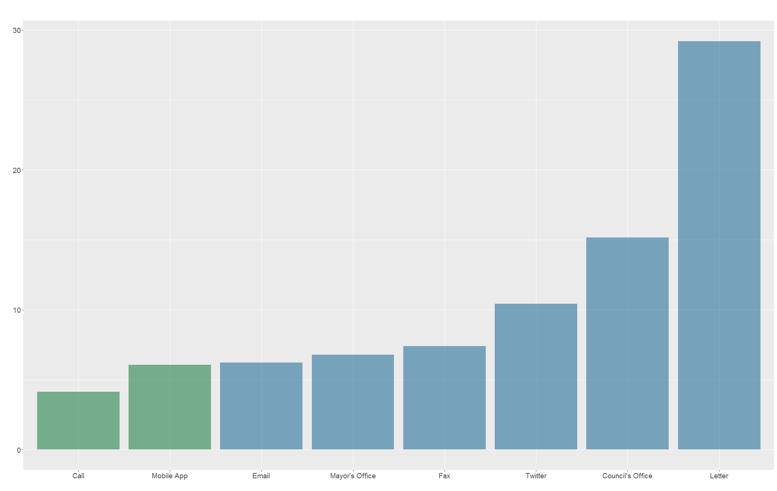

This barchart shows the breakdown of handle time by request source. We observe that requests that are made through mobile applications and calls are resolved the quickest whereas writing a letter request takes the longest to resolve.

## *Time Series/Efficiency in Handling Requests*

**Heatmap of Service Requests: Day vs. Hour**

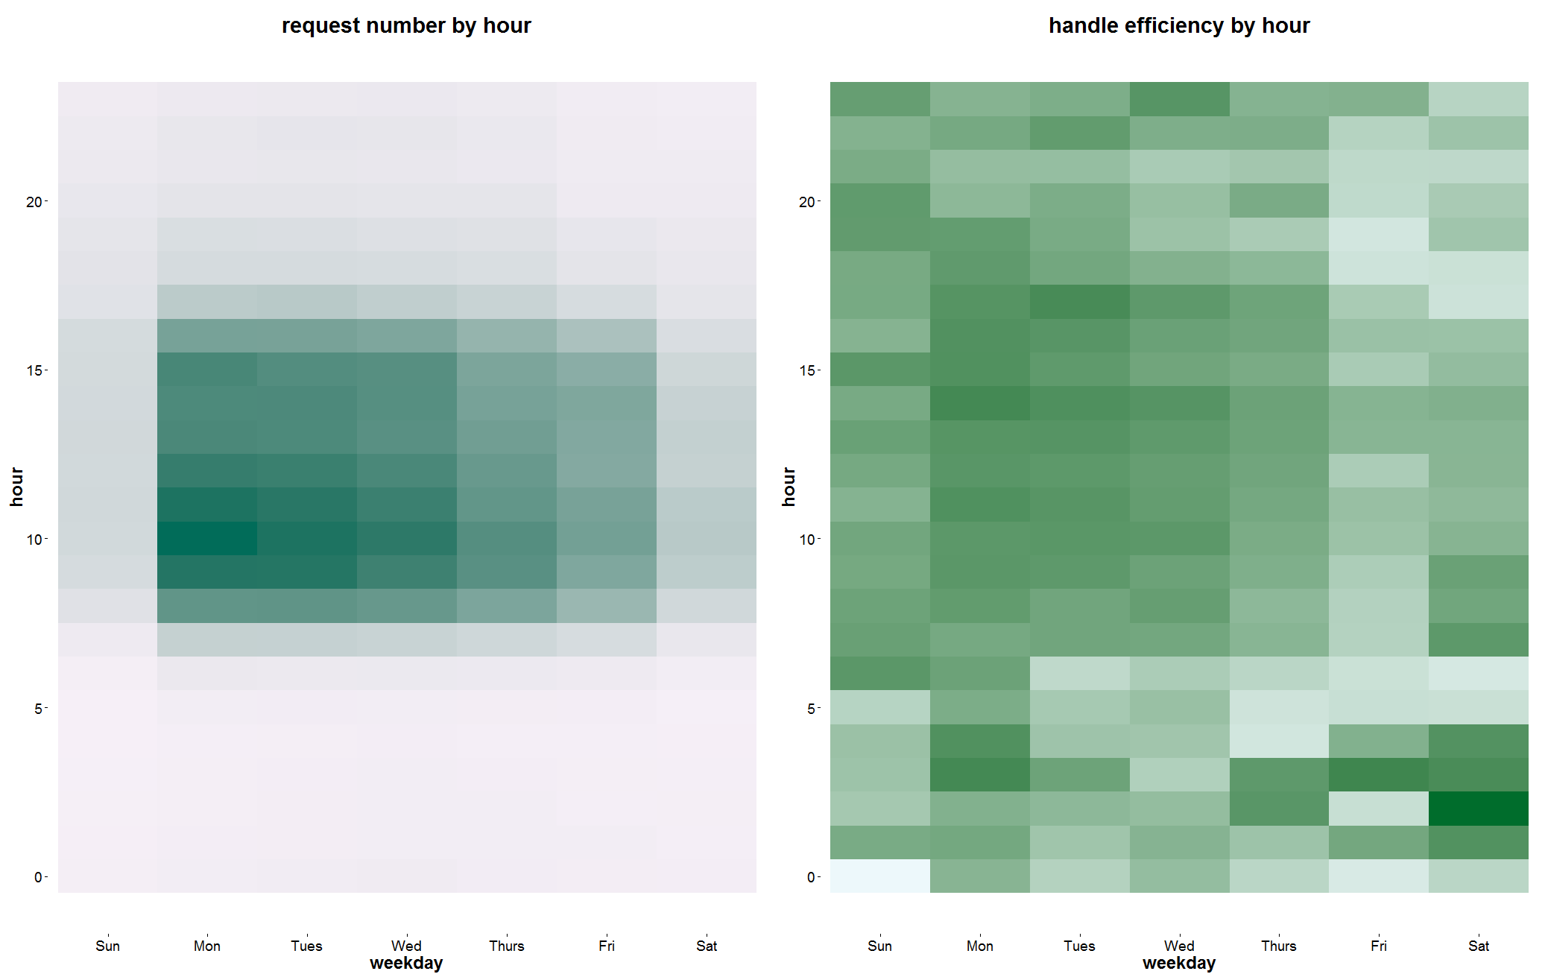

We took a look at the busiest times for the 311 service department compared to the department’s most efficient times at handling requests. The way our team calculated efficiency was the difference in days between the date the service request was last updated (closed) and the date the service request was created. The darker areas of each heat map represent the busiest/most efficient times. From these charts, we can observe that the city tends to be relatively consistent in receiving and handling requests, indicated by the high number of requests generated and handled Monday to Wednesday.

**Request Number vs. Handle Time**

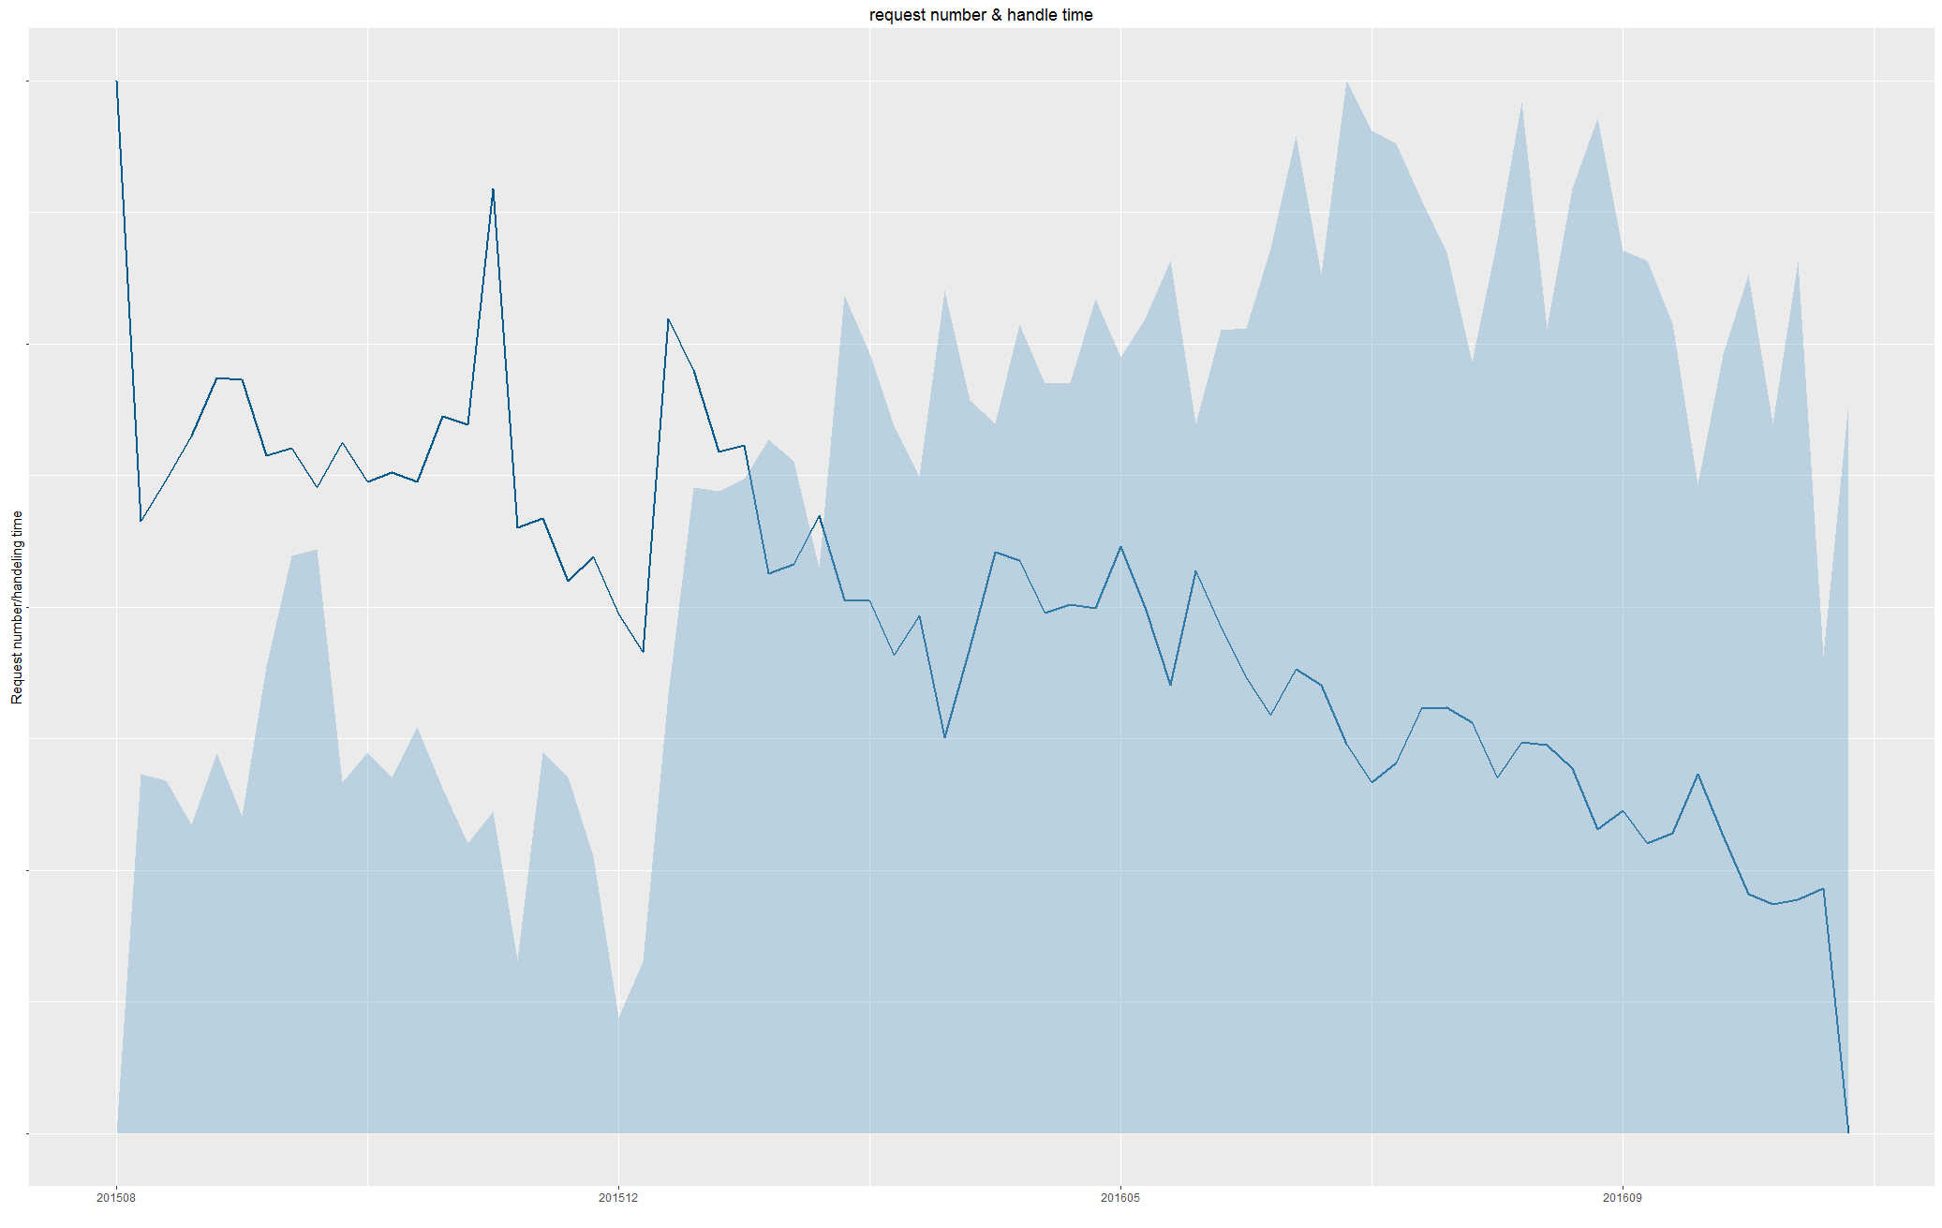

This chart shows total the number of requests created over time (indicated by the solid blue contour plot) versus the total handling time of those requests (indicated by the blue line). Over time, we observe that more requests are generated and that these requests take less time to complete, indicating that the departments are becoming more efficient.

## *Maps/Spatial Visualizations*

**Population Density vs. Requests**

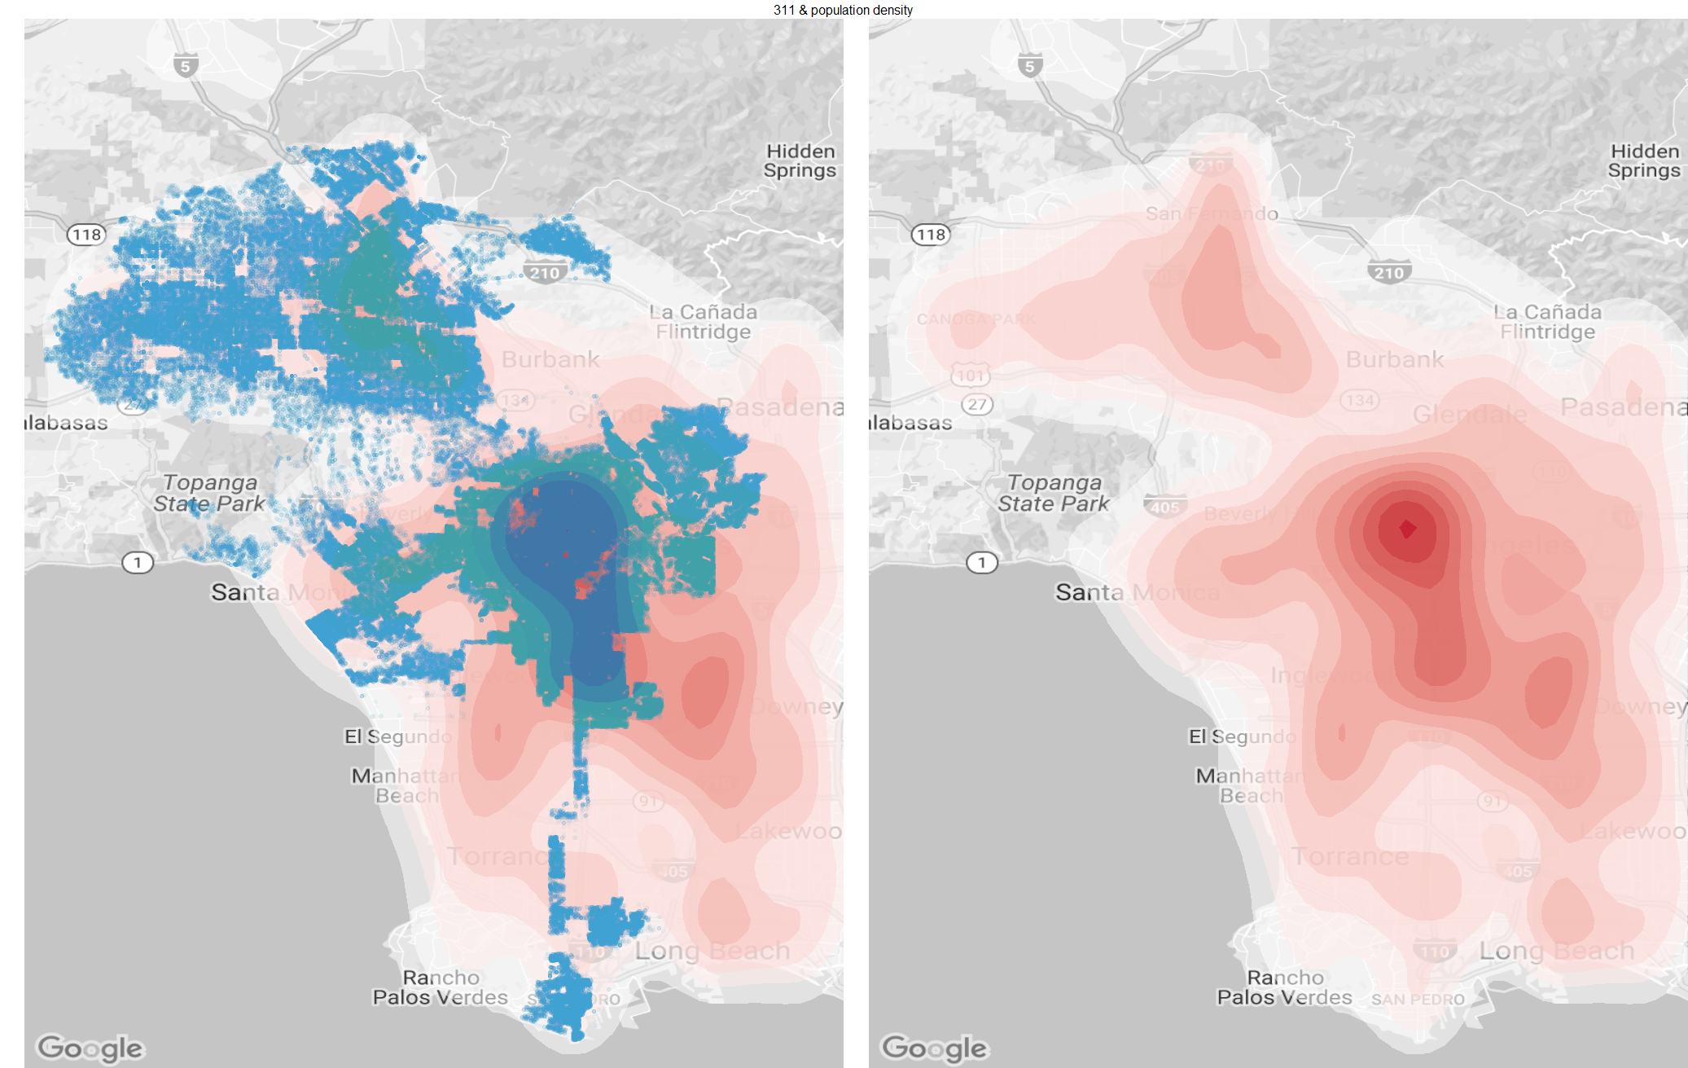

The charts above show the population density in Los Angeles versus the number of requests generated (population in red; requests in blue). Generally, there is a slight correlation between population and number of service requests created. However, it is important to note that even areas that are more sparsely populated in the San Fernando Valley and the South Bay display high request frequency.

**Income Level vs. Requests**

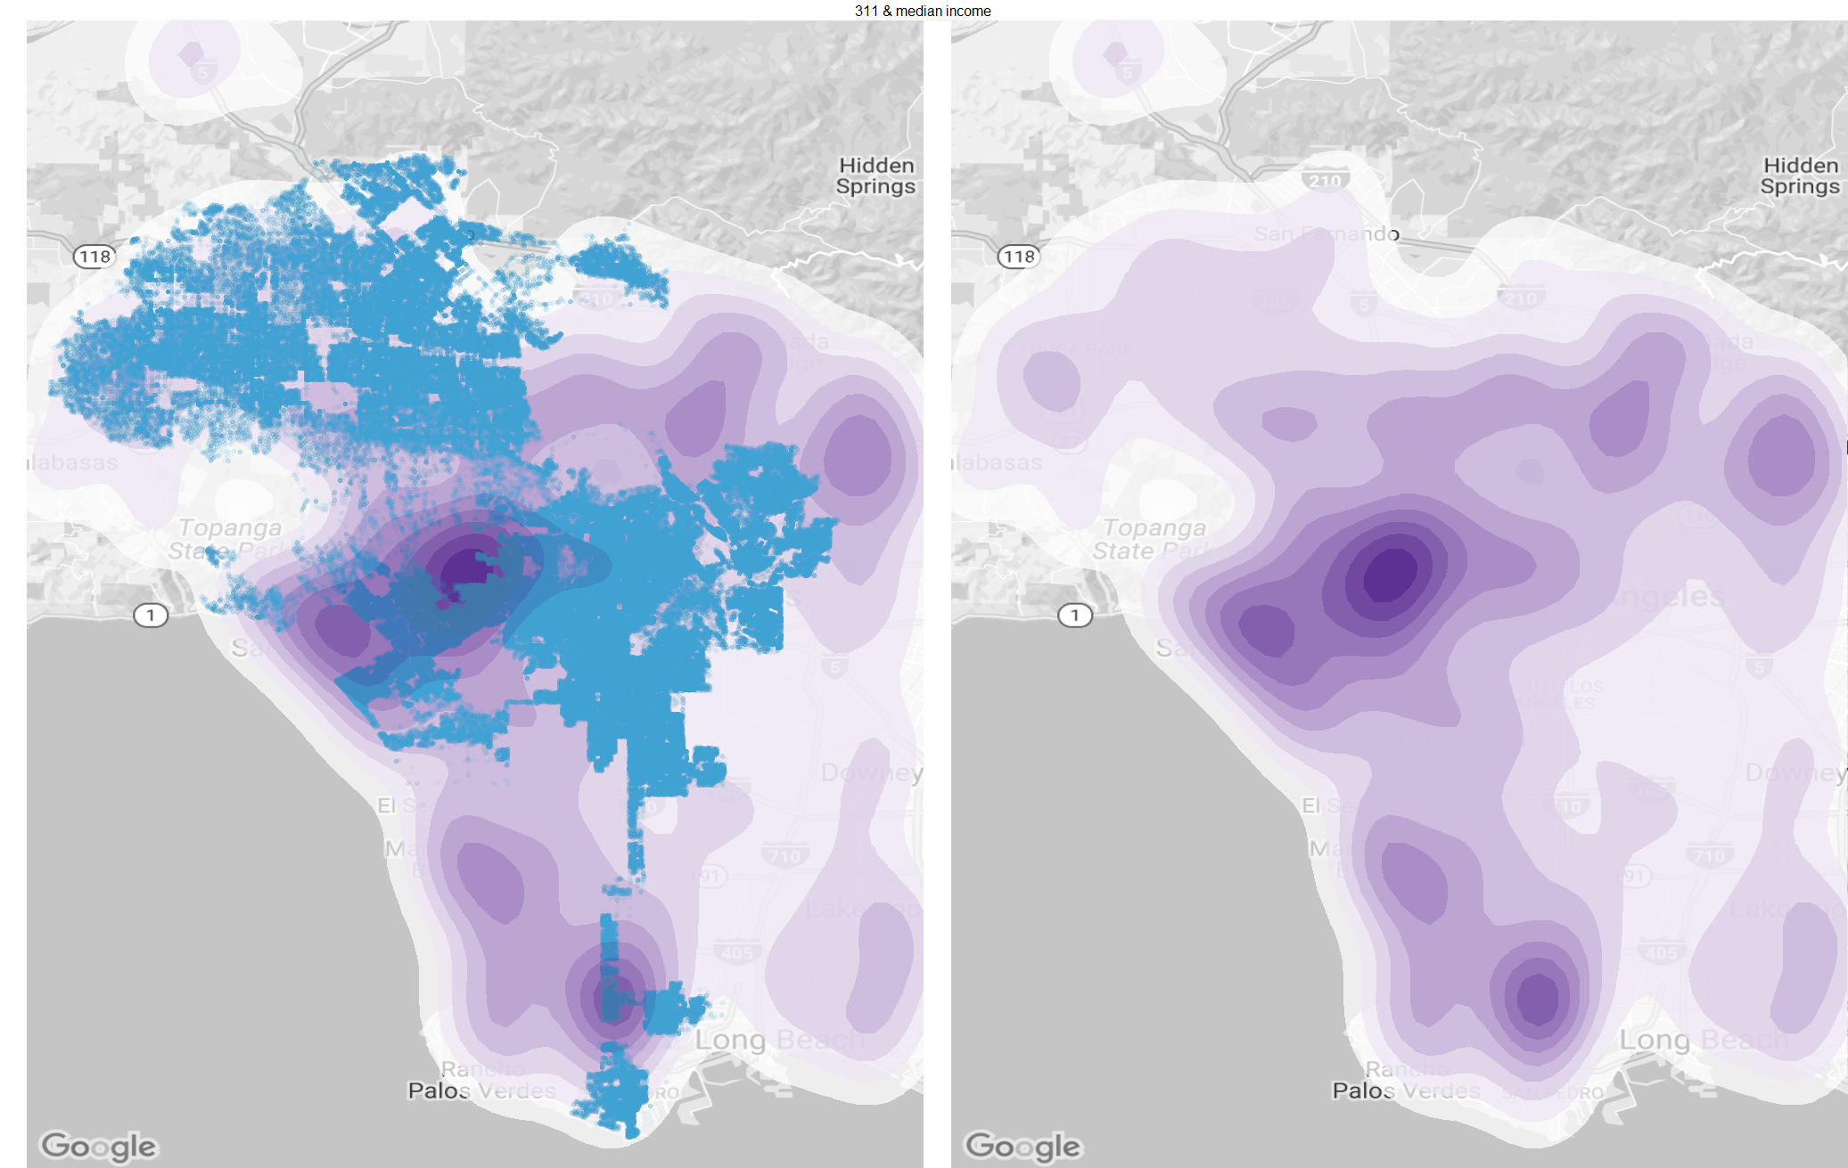

We also decided to analyze if income level had any correlation to request frequency (income is blue; requests are black). This explained some of the discrepancy we were seeing with the population data, particularly in the South Bay area. In general, we can conclude that request frequency is more positively correlated with income level than it is with population.

**Income vs. Water Waste**

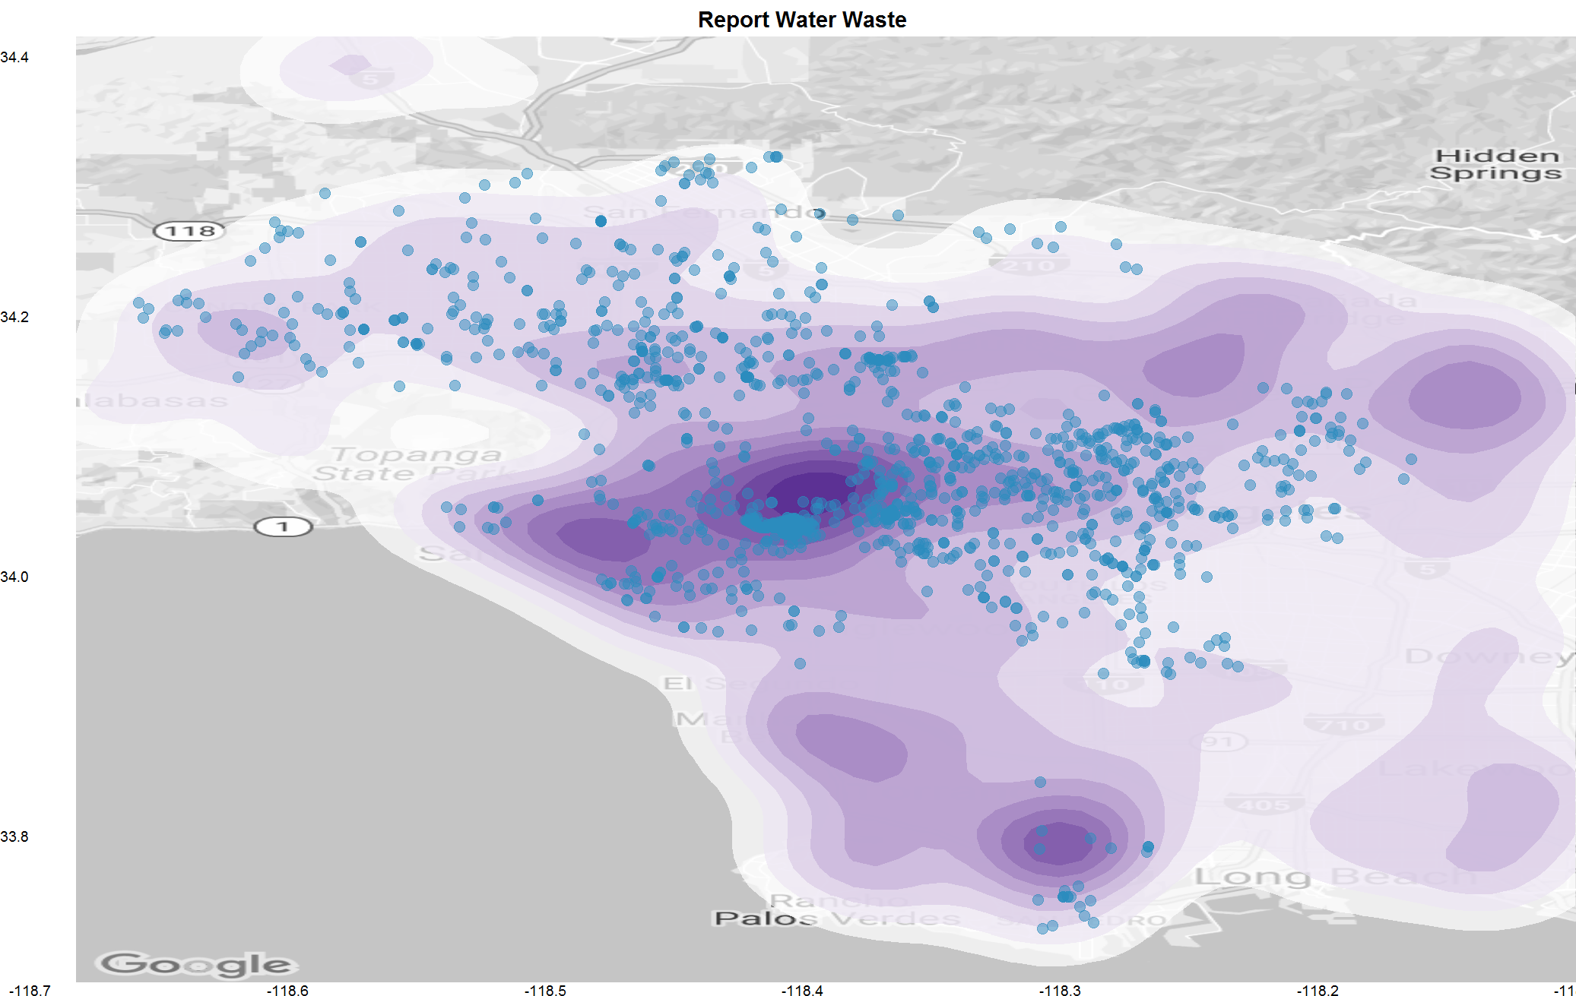

We looked at various request types to see if there was any correlation to income level. We found that water waste requests (black dots) had a particularly positive correlation to income level. Higher income households may be more ambivalent about conserving water because they are not as concerned with higher water bills.

**Illegal Dumping**



Illegal dumping mainly occurs when non-residents take advantage of pick-up services in neighboring cities and illegally dump trash in that city. Observing data from Council District 8, we can see that there tends to be a higher number of illegal dumping requests generated on Thursday than any other day of the week. The Bureau of Street Services (BSS) schedules street sweeping service from Monday to Thursday. The main focus should be on how to lower this request type. One strategy could be to form a joint task force made up of community members, law enforcement, and local government agencies. If any patterns of suspicious activity are observed, law enforcement should be ready to act swiftly. Assigning a full-time investigator to work with the city across relevant agencies is another strategy.

**Homeless Encampments**

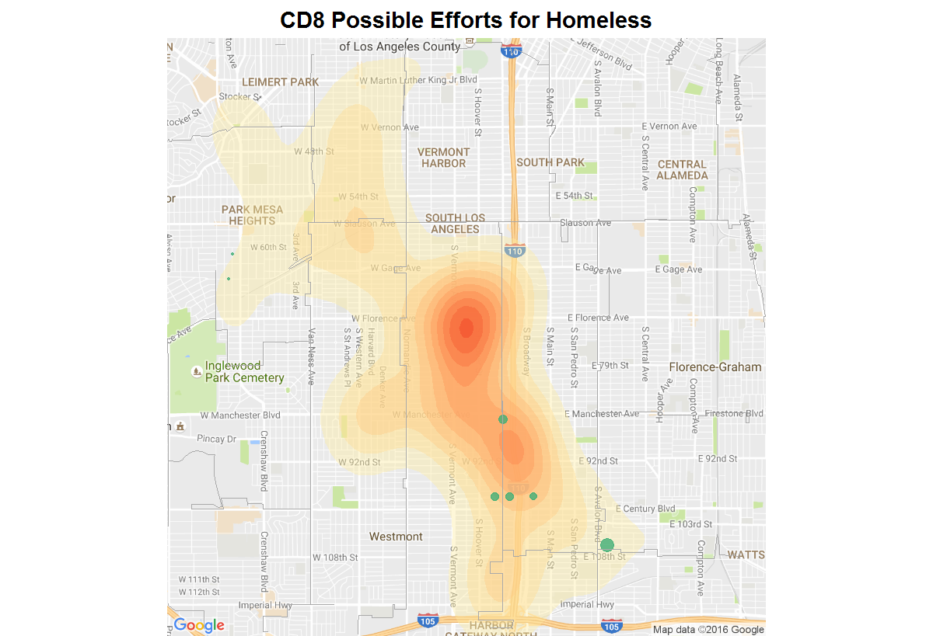

As winter approaches in LA, the homeless problem is particularly challenging, especially in areas near downtown. We took a look at the number of homeless encampment requests in Council District 8. Additionally, we took a look at another dataset in LA Open Data called “Map of Possible City-Owned sites for Homeless Efforts in CD8” to view different potential homeless shelters being built in the area (green dots indicate future shelters; size of dots represents square footage of shelters). Overall, it seems like the city is doing a good job of placing shelters near problem areas, but it will be important to continue to monitor the situation after the shelters are built to ensure there is enough capacity to handle the number of homeless and that the location of each site is close enough to problem area to logistically make it feasible.

**Water Waste**

**No Outliers**

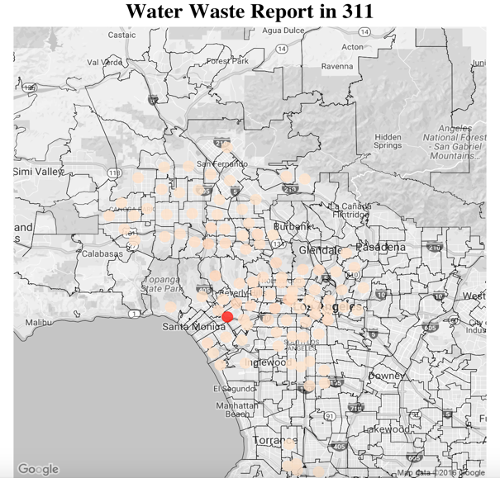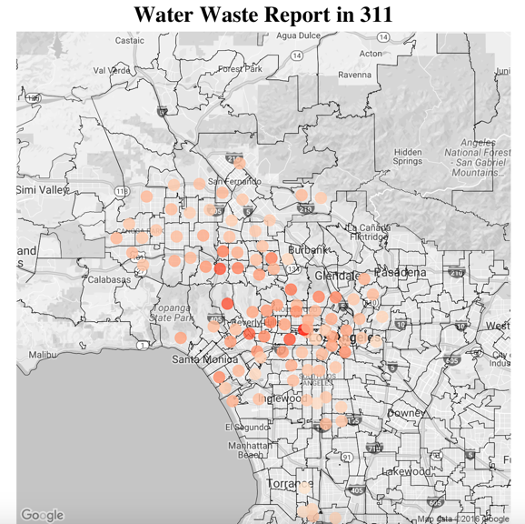

Given that the state of California is currently in a drought, we decided to take a look at the number of water waste reports generated based on location in the city. However, after drawing our graph, we initially found an outlier zip code where the volume of water waste reports was so much greater, that the other data points are too small to be differentiated. The outlier zip code appears to be in the West LA region near UCLA. This is significant because, according to the news on July 30, 2014, a water pipe burst on UCLA’s campus spilling nearly 75,000 gallons per minute. While this 311 data is from 2015 and 2016, it may be that residents in that area are on high alert following the UCLA incident and are reporting water waste with higher frequency.

If we take out the outlier data point, we can see that the data is much more normally distributed across the city of LA. Areas like West Hollywood and Sherman Oaks tend to be hotspots for water waste, which is reinforced by our Income vs. Water Waste graph above.

# **RECOMMENDATIONS**

*Rec 1: Continue to drive traffic to MyLA311 Mobile App*

The 311 department should use search engine optimization in Google and the App Store to increase awareness of the MyLA311 mobile app when users search for 311 service. The ability to collect and synthesize data in real time through the mobile app will be extremely beneficial not only for speeding up the request to service time, but also in observing historical trends.

*Rec 2: Identify request types with long handle times and optimize resource allocation to improve 311 service efficiency*

What, if any, is the bottleneck that is occurring? Is it the nature of the request? Possible communication breakdown between government agencies? Once the issue is identified it will be easier to disperse the proper resources to address it.

*Rec 3: Connect 311 data set with other department datasets to foster more collaboration between agencies*

Collecting more data points from other departments can help generate more targeted insights into specific issues.

# **CONCLUSION**

The 311 service is intended to divert non-urgent concerns from 911 related emergencies. In this respect, the city of Los Angeles provides its residents a valuable, efficient way to deal with routine inquiries. However, as more historical data from the service requests becomes readily available, it will be important for the 311 office to continually look for ways to optimize its service offering and handle requests more efficiently.

# **SOURCES**

"Improving Livability In Los Angeles - CLEAN STREETS LA - City Administrative Office March 2015"

Link:http://cao.lacity.org/Reports/06150112%20Improving%20Livability%20in%20Los%20Angeles-Clean%20Streets%20LA.pdf

"L.A. City Budget 2016-2017"

Link:http://www.la32nc.org/2016/05/2016-2017-city-budget-emphasizes-improved-services/